# daq.io API Toolkit Quick Reference Guide

**The** [**daq.io**](http://daq.io) **API for NI LabVIEWTM allows you to work with your measurement data in the online data storage platform** [**daq.io**](http://daq.io)**.**



Index

daq.io API Toolkit Quick Reference Guide 1

The daq.io Platform 2

The daq.io Services 2

Free account 2

The daq.io Data Structure 3

Warning 3

How to access daq.io 4

Getting started 4

daq.io welcome screen – Device Management 5

The Dashboard 6

The Dashboard Editor 7

Analyze existing data – The Data Viewer 9

Other ways to access your daq.io data 9

Access your data via http(s) REST interface 9

Interfaces to third-party tools and platforms 10

The NI LabVIEWTM daq.io Toolkit 11

Requirements 11

Installation 11

Getting started logging data to daq.io 14

# The daq.io Platform

The daq.io platform provides online storage, management and analysis functionality for time series measurement data. It is a great solution to store and document any type of distributed measurement online. Based on a scalable, powerful database, daq.io easily adapts to growing demands for storage capacity and processing power. Furthermore, your data is always protected thanks to state-of-the-art SSL encryption.

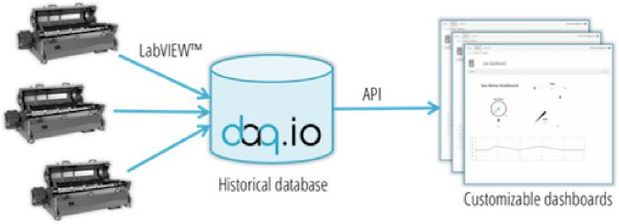

Figure 1: Basic architecture of the daq.io platform

## The daq.io Services

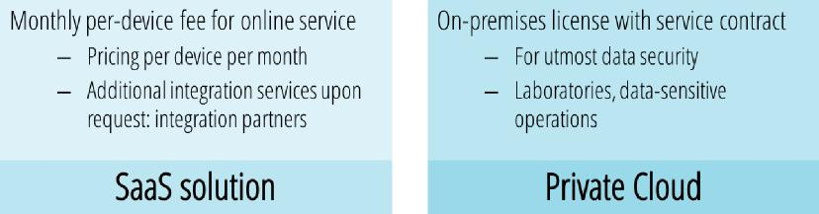

Figure 2: Two different service option: SaaS vs. Private Cloud

Depending on your application profile, you can choose to either have your machine and measurement data hosted at trusted cloud storage providers or to host all data yourself, giving you absolute control over your data. Contact info@daq.io for more information.

## Free account

In order to try out daq.io and visualize small amounts of data (50 MB max), daq.io provides a free instant account. Older data will be truncated once the maximum data threshold is reached.

## The daq.io Data Structure

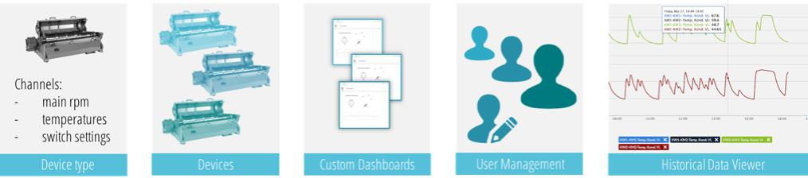

Figure 3: Elements of the daq.io online platform

The daq.io platform is designed to allow easy online device configuration and management. Typical applications include collecting data from distributed custom machines at various sites, monitoring prototype devices or even centralizing distributed testing locations.

A Device is the entity that you would like to monitor. For instance, a large centrifuge at a specific customer site. If you deployed many similar or identical machines, you can define a Device Type that describes all available data channels, possible alarms and events, and useful tags for additional machine information (e.g. last maintenance date, etc.).

A Device and its Device Type can be defined both on the online portal or using the daq.io LabVIEW toolkit VIs. When you defined a device type, simply roll out these settings to a number of devices by running the identical LabVIEW code on the data logging machines.

The daq.io website allows you to easily create and edit custom dashboards to visualize distributed data. Furthermore, you can manage user accounts: Simply add users and their respective roles to manage them later. The Data Viewer allows you to analyze and export historical data for all connected devices.

## Warning

While data in the [daq.io](http://daq.io) platform is continuously being backed up, it is highly recommended to save any data that is being sent to or received from the [daq.io](http://daq.io) platform and perform regular archiving backups of all relevant data.



# How to access daq.io

## Getting started

In order to use the daq.io service, simply sign up with daq.io.

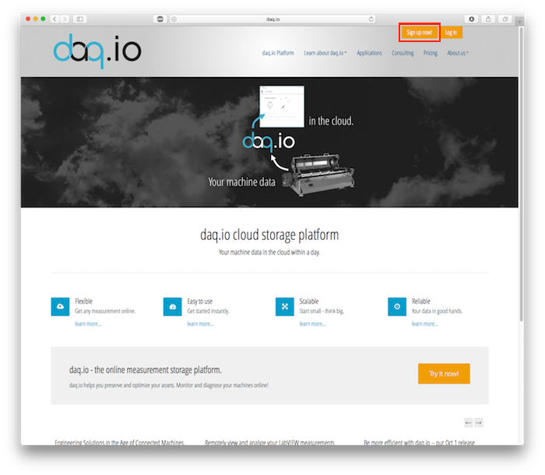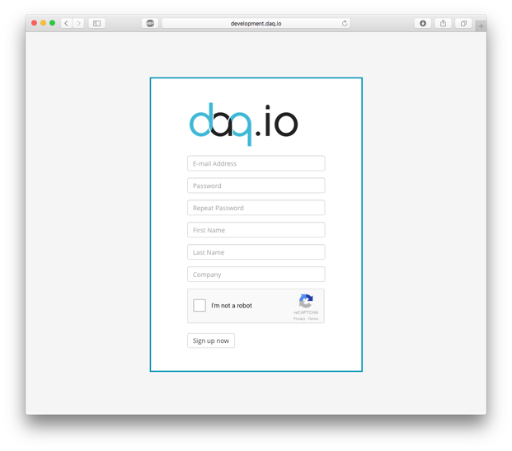

Figure 4: Two simple steps to sign up with daq.io

Register with www.daq.io for a free account. You can sign up instantly for a free account that you can use to try out the remote monitoring capabilities of daq.io.

Upon successful registration, you can immediately log in with your account data at dashboard.daq.io. You are now ready to use daq.io.

## daq.io welcome screen – Device Management

After logging in, you are presented with the overview of all your existing devices. This is your starting point to managing all existing devices, changing device settings or adding new devices. The fastest way to create a device is to run the LabVIEW Machine example.

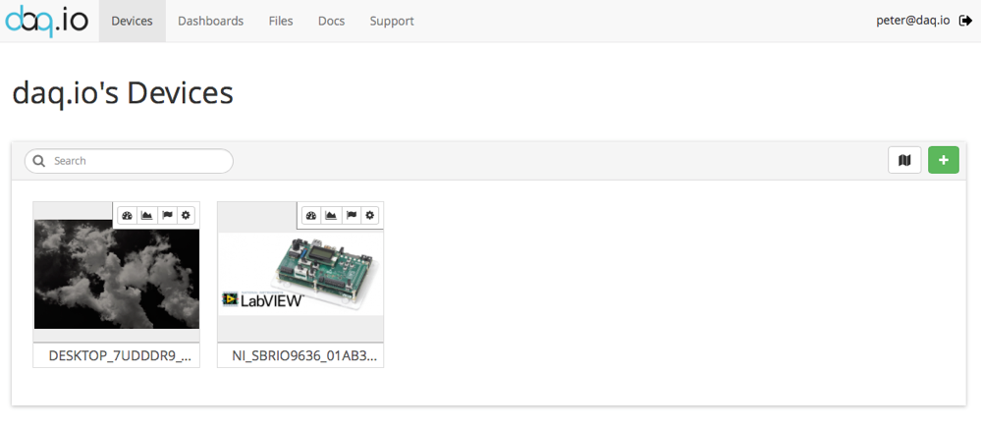

Figure 5: Device overview in Device Gallery

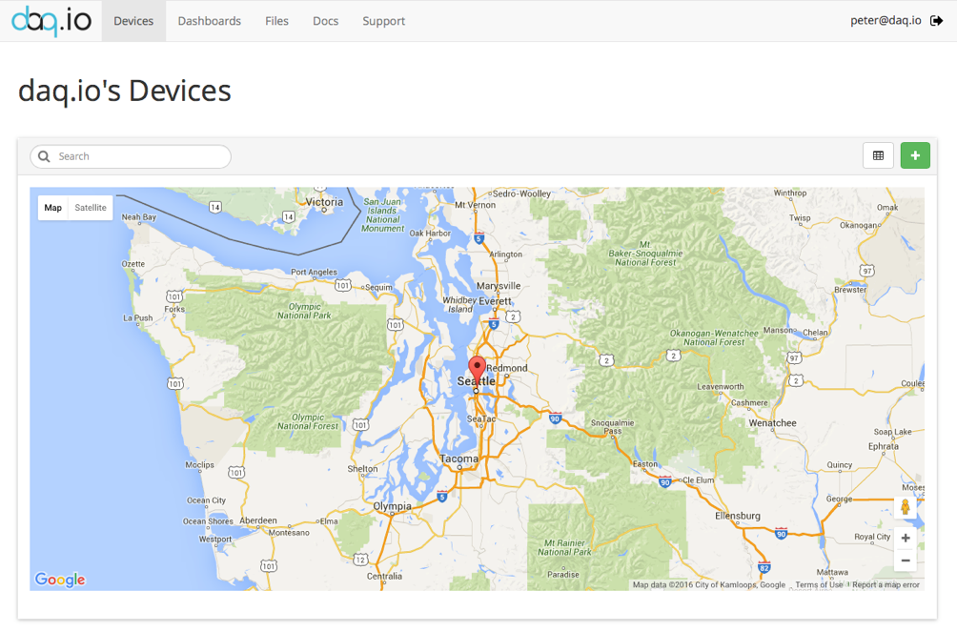

Figure 6: Device overview in Map mode

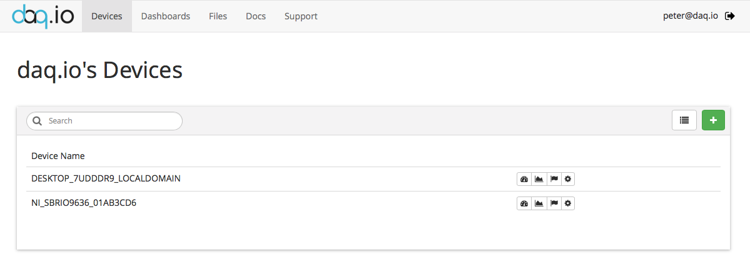

Figure 7: Device overview in Table mode

Each device has small icons on its top-right corner, indicating the short links to the device’s dashboard, its historical data and all device settings.

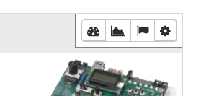

Figure 8: Device shortcuts

The leftmost dashboard link will open the associated dashboard that presents all live values for the device.

## The Dashboard

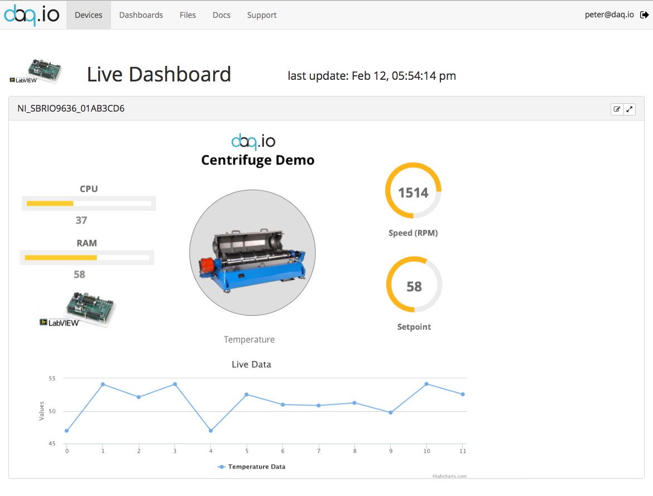

Figure 9: Example of a live dashboard

To create and manage your own dashboards, switch to the “Dashboards” tab. Here you can get an overview of existing dashboards, edit them or create new dashboards. Like in the Device overview, you also view your dashboards as a table.

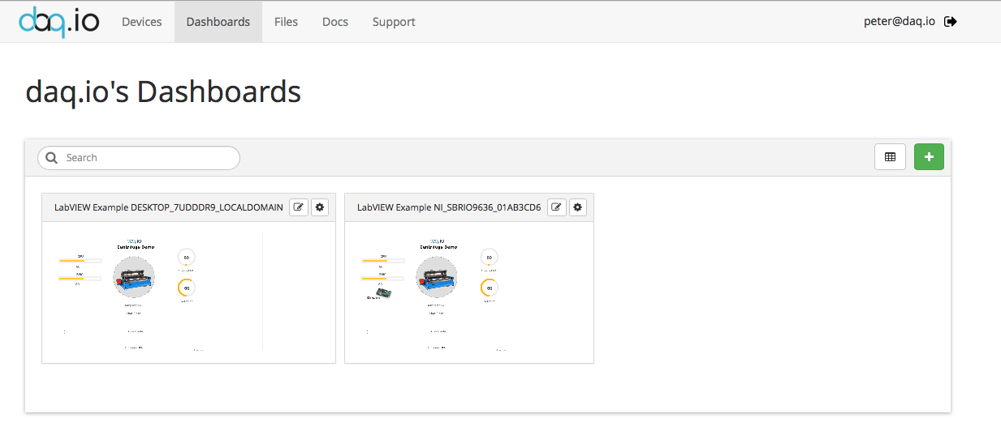

Figure 10: Dashboard overview

By clicking the “Settings” button, you can change the dashboard’s settings, such as its name. Clicking the “Edit” button will open the Dashboard Editor.

## The Dashboard Editor

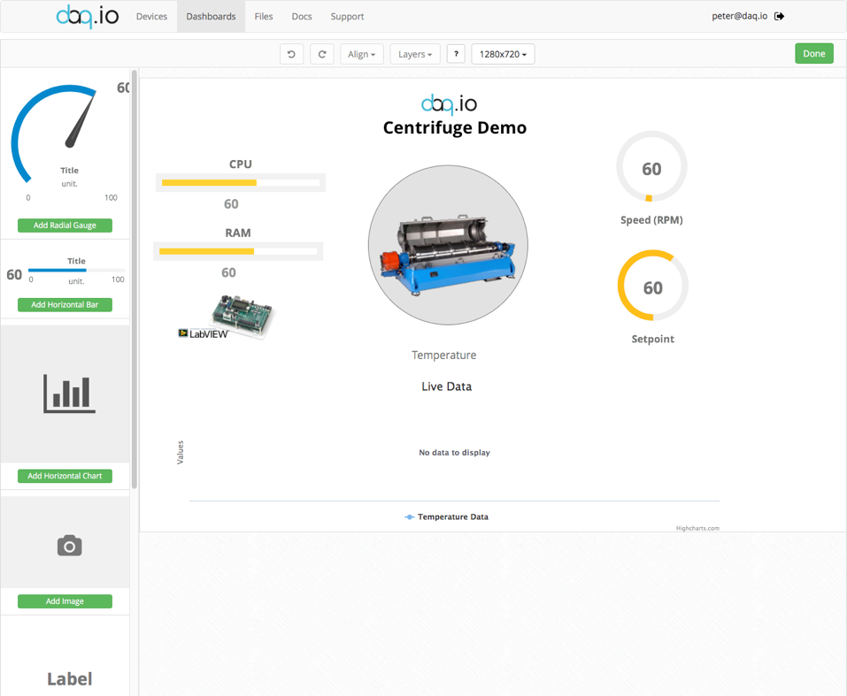w

Figure 11: The Dashboard editor

Add Gadgets from the toolbox on the left by clicking the green “Add...” button.

Change a gadget’s setting and link it to a device channel by clicking on it after it has been placed on the dashboard. A settings window will pop up and allow you to adapt the gadget to your needs. You can also choose between multiple themes and styles.

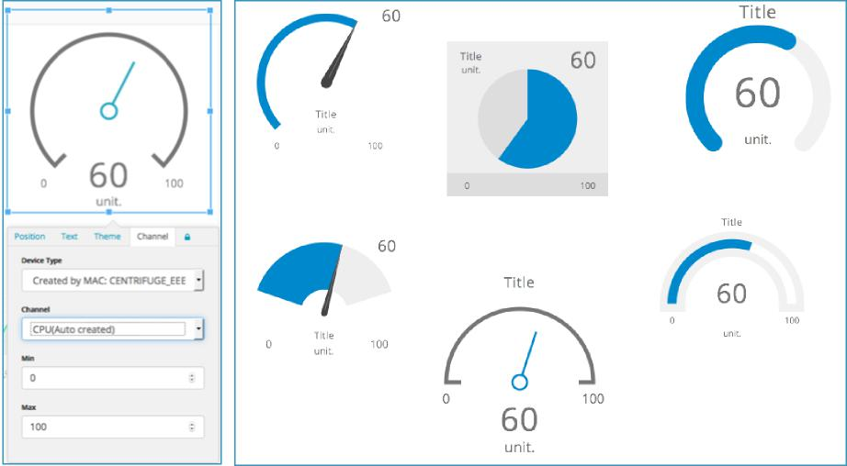

Figure 12: Gadget menu, gadget themes and styles

The dashboards are implemented in pure HTML and can be viewed from any modern browser and device. No plugins are required.

## Analyze existing data – The Data Viewer

Use the Data Viewer to analyze all the existing time series measurement data of your devices. Access the Data Viewer from the device’s second shortcut button.

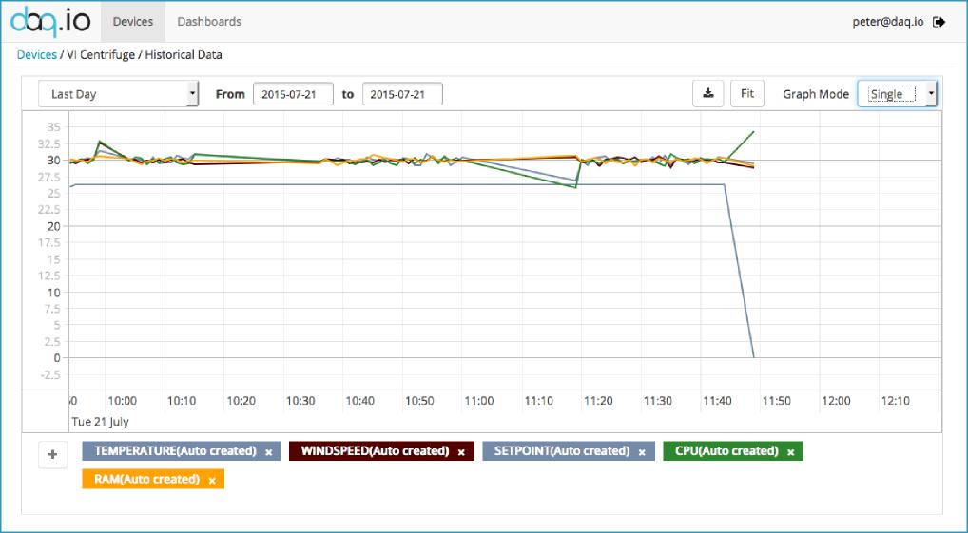

Figure 13: The Data Viewer

The Data Viewer lets you select all channels that are available for the existing device. You can select between a single and a stacked chart. Zooming in will return more detailed values. A plot legend allows you to remove and add channels to compare values visually. Chart data can be exported as CSV files for further analysis.

# Other ways to access your daq.io data

## Access your data via http(s) REST interface

While you can easily use the provided LabVIEW VIs and the web frontend to access and manage your data and devices, the daq.io platform also securely provides your measurement data via a REST interface for any third party programming language or device.

The concept of a REST service is defined as follows: The requested resource is accessible via a web server and it is uniquely identified by a URI. Standardized http requests are used to transfer data. This eliminates the need for proprietary protocols or software products, thus ensuring high compatibility.

Data is being presented in the “JSON” format, which is a common UTF text format. It is completely platform independent and easy to implement. JSON consists of an ordered list of objects that contain key / value pairs of data.

For a full documentation of the API, go to <http://dashboard.daq.io/#/docs>.

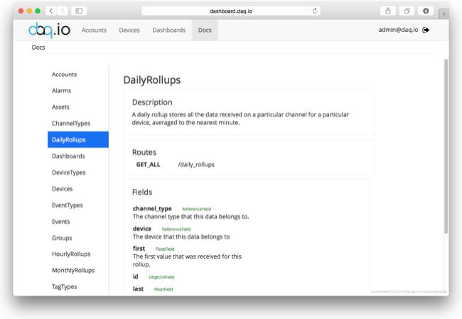

Figure 14: daq.io API documentation online

## Interfaces to third-party tools and platforms

daq.io can provide and refer custom integration services to adapt the daq.io platform to your requirements. Contact us at info@daq.io.

# The NI LabVIEWTM daq.io Toolkit

Supported functionality

* Communication
  + Open connection to the API
  + Close Connection
* Interaction with the API
  + Write Data to daq.io
  + (Create and) Update Tag
  + (Create and) Fire Event
  + Get all Device Events
  + Upload Files
  + Download Files
* Calls to specific API Routes

A detailed overview of VIs and API functions can be found in the functions overview.

## Requirements

LabVIEW 2013 or newer.

JKI Package Manager 2014 or newer.

Internet access with HTTPS support.

## Installation

Find the daq.io AddOn in the LabVIEW Tools Network using the JKI VI Package Manager (Figure 15). Simply select “Install&Upgrade Packages“ to add the daq.io API toolkit to your LabVIEW installation.

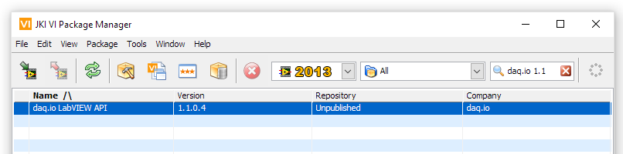

Figure 15: JKI Package Manager 2014 with the daq.io package selected

Upon successful installation, a new palette will be installed in LabVIEW that can be found in the “AddOns“ function palette of the block diagram.

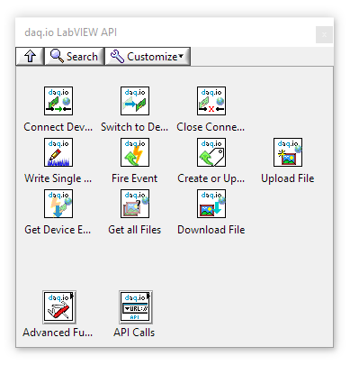

Figure 16: daq.io API palette in "AddOns"

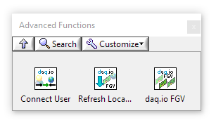

Figure 17: Advanced VI sub-palette

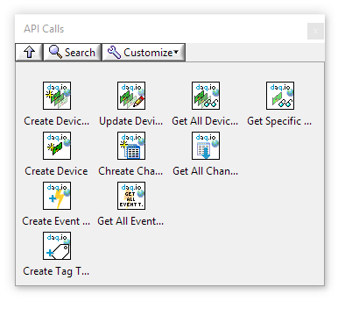

Figure 18: API Routes sub-palette

Also, examples will be added to the LabVIEW Example Finder. Find them by selecting “Help” -> “Find Examples” in the LabVIEW menu. In the Example Finder, search for “daq.io“ (Figure 19).

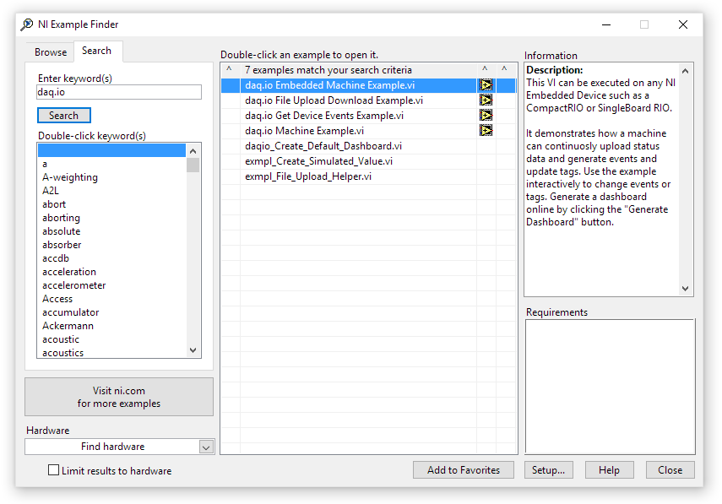

Figure 19: daq.io examples in the NI example finder

## Getting started logging data to daq.io

Running this simple example will accomplish the following:

* The LabVIEW VI will create a new device and device type for demo purposes.
* It will continuously upload data and events to your daq.io account
* You can generate events, update tags from the example
* Clicking “Create Dashboard” will generate a dashboard online so you do not have to build one.

Simply open and run the “daq.io Machine Example.vi”. You will need an active account on daq.io to upload and view data.

Log in on the front panel and click “Next” to move between the application’s tabs that explain what the program is doing in the background. On the “Tags” tab, you can edit existing values.

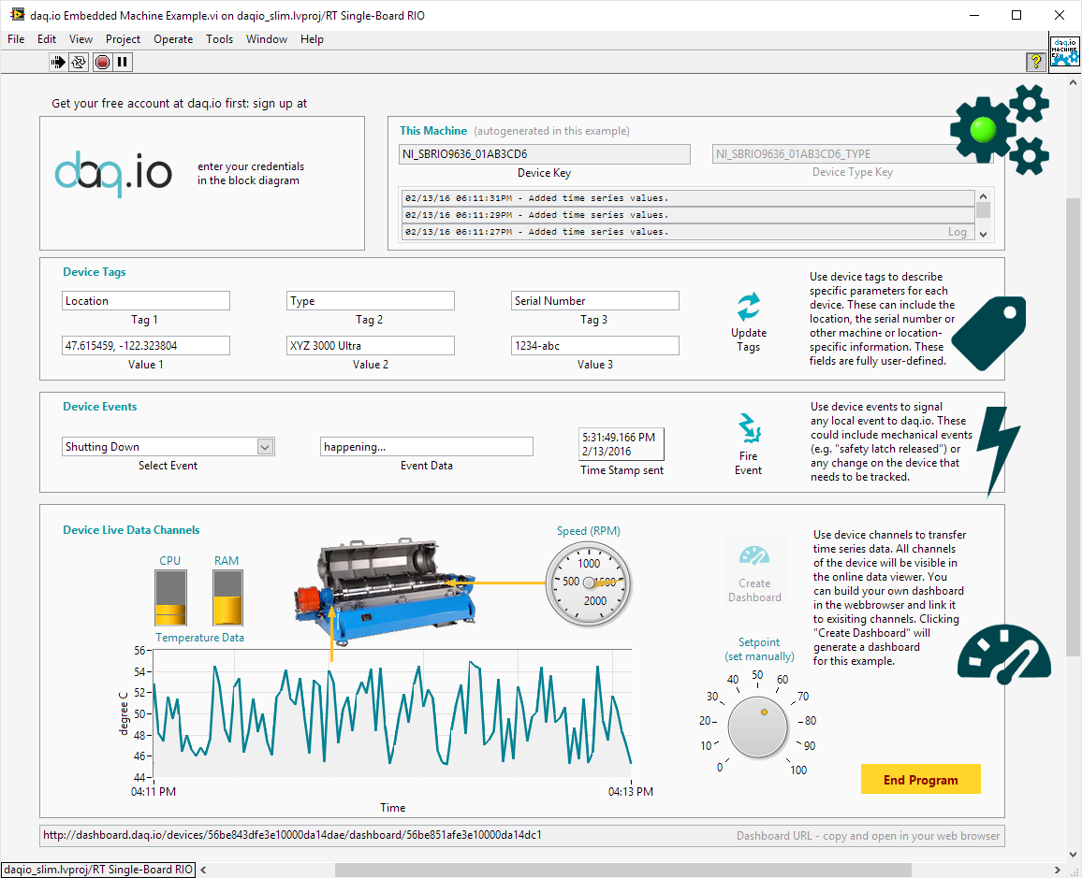

Figure 20: daq.io Machine example

If you are running the example for the first time, click the “Generate Dashboard” button. It will generate a dashboard for your currently running example on daq.io.

Open a browser window and log on to dashboard.daq.io to view the live data and the historical data your device has been logging.



Figure 21: Dashboard generated by and for the example

Support and Feedback

Please contact us at [info@daq.io](mailto:info@daq.io)

For latest news and support on our toolkits, go to

<https://decibel.ni.com/content/groups/daqio-support-forum>

© Copyright 2016 - daq.io, LLC – [www.daq.io](http://www.daq.io)

daq.io LLC

P.O. Box 20692

Seattle, WA 98102

USA